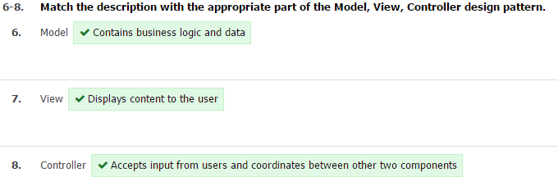

Which of the following is NOT true of processes

* They run inside of threads
* They run in separate memory spaces from each other
* They take more resources to create and destroy than threads
* They are currently active in memory (e.g., RAM)

Which of the following is NOT part of a standard 3-tier architecture?

* Database Server
* Web Browser
* Web Server
* Middleware

Apache can be run in two different modes: 1) it creates a new process for each visitor, or 2) it creates a new thread for each visitor.

**True**

False

Javascript can pass a function as a parameter.

True

False

Which of the following is NOT true of Node.js

* Node.js includes Chrome's Javascript Runtime environment
* Node.js is a web server
* Node.js uses the asynchronous, event-driven, single-threaded model.
* Node.js uses Javascript on the server

Long Polling is the recommended method for server initiated events

True

False

Web Sockets are considered an HTTP upgrade.

**True**

False

When logging in using OpenID administered by a third party (e.g., Google), the site that you are visiting (e.g., the memes site for your lab) stores your password or a hash of your password.

True

False

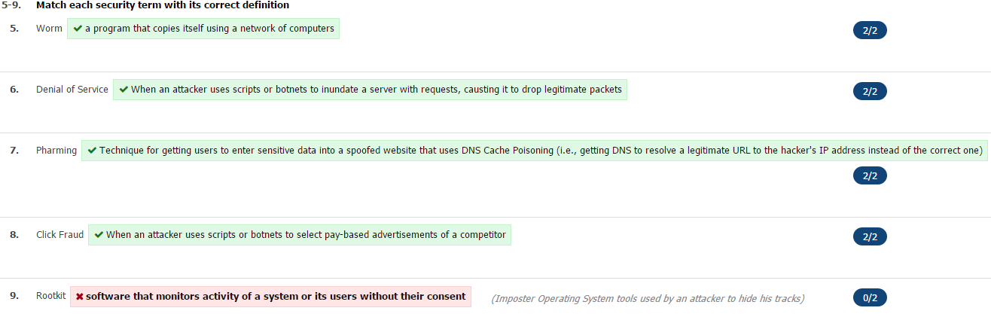Which of the following is NOT true of Websockets

* It is a protocol
* It allows clients to initiate communication between client and server
* It allows servers to initiate communication between server and client
* 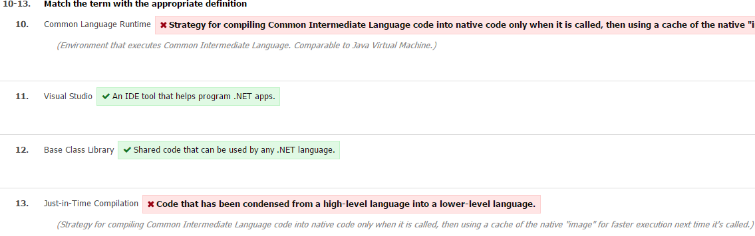It is synchronous (i.e., blocking), meaning that multiple communications must happen one after the other

An IMG HTML tag can serve as a vector for a Cross Site Scripting attack.

**True**

False

The Internet was designed from the start with security in mind

True

False

Output encoding user-generated content stored on the server will protect against Cross Site Scripting (XSS), but not Sequel Injection.

**True**

False

ASP.NET (.aspx) files are fully compatible with ASP (.asp) files.

True

**False**

ASP code can be embedded into an HTML page and will be executed by the browser.

True

**False**

It will be executed by the server

A person can fall victim to a Cross Site Scripting attack by simply visiting a URL

True

False

The OnStar automobile system that can access the Internet if a car breaks down is an example of what?

* Content Management System
* Mobile app
* Embedded system
* Dedicated mobile site

Server-side analytics tools can have historic data available in reports immediately after installing them on the server.

**True**

False

Social media technologies change "one to many" communication into "many to many" communication.

True

False

Users of a Content Management System must be able to code in a native language to use the tool

True

False

Embedded systems are typically immune to security problems because they are single-purpose and limited in their functionality.

True

False

CSS Media Queries can be used to serve custom CSS to different devices based on their screen width.

**True**

False

An Application Programming Interface (API) allows a coder to access data or use functionality from a third party site (e.g. Twitter).

True

False

Which of the following is NOT true of Python

* It uses indentation instead of brackets
* **Version 3.x is compatible with version 2.x**
* It is loosely typed
* It is a mature object oriented language

"Ubiquitous computing" as originally envisioned sees a future where computers are all over, yet they fade into the background

**True**

False

Firewalls blocking access to analytics tools can be a problem for...

* client-side analytics tools
* **server-side analytics tools**
* both client- and server-side analytics tools
* neither client- or server-side analytics tools

Which of the following is NOT a technique that can be used for "browser/feature sniffing"?

* **Xpath Feature List broadcast mechanism**
* CSS Media Queries
* Modernizer Javascript library
* Device repository such as WURFL

What will be printed with the following code?  
  
str = 'purple alice-b@google.com monkey dishwasher'  
match = re.search(r'\w+@[\w.]+', str)  
if match:  
   print match.group()

* alice-b@google.com
* b@google.com
* b@google
* 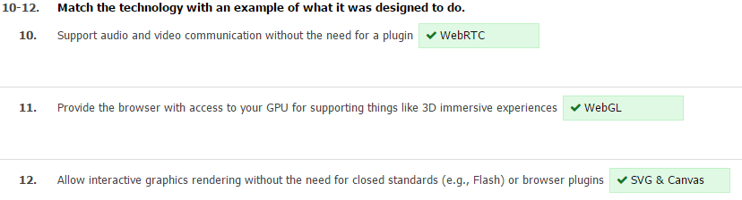purple alice-b@google.com monkey dishwasher

Which of the following is NOT part of the iron triangle (project management triangle)?

* Resources
* **Complexity**
* Time
* Scope

Which of the following is NOT an iterative programming model

* Agile programming
* SCRUM
* Waterfall model
* Spiral model

One advantage of using Software as a Service is the reduction in bandwidth that is used.

True

False

One disadvantage of using Infrastructure as a Service is that you lose some control over the privacy of the data that is being housed.

**True**

False

CSS Media Queries are used to query a database from the client-side.

True

False

All featuers of CSS3 are fully supported by the most recent version of Chrome and Firefox.

True

**False**

Open standards typically lead to increased competition.

True

False

Canvas uses vector graphics so it can be scaled to any size and still look good.

True

False

The regular expression: Welcomes*  
will match the word Welcome

**True**

False

In regex, \w matches all uppercase letters, lowercase letters, digits, and the _ character.

True

False

A Cron job in Linux can run scripts at various intervals of time.

True

False